Pcard Expense Report Instructions
RECONCILING YOUR PCARD ACCOUNT
- Access the Wells Fargo CCER website at - https://wellsoffice.wellsfargo.com/ceoportal/signon/
- Enter your log in credentials - Company ID = unive638, User ID, Password
- Select the “Sign On” button
- The Wells Fargo CEO home page will appear
- Select “Commercial Card Expense Reporting” (CCER)
- Your “Open Statement” expenses will appear in numbered sequence (Open Statement is the previous months expenses that became available for reconciliation on the second day of the following month). There may be more than 1 page.
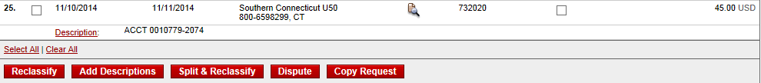
- Select the box next the item you want to reclassify
- Select the “Reclassify” button
- The screen pictured below will appear providing detailed information for the expense to be reclassified.
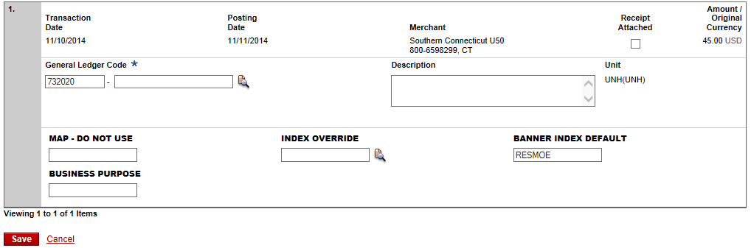
4) Enter an 18 character business purpose
5) Enter a 200 character business description
3) Override the default Index from the drop down menu if the default Index is not correct
1) Select the GL code from the drop down menu
6) Select “Save”
2) Keep the default Index if it is correct
- Select “Return to Charges – Manage Charges” near the top left of screen. 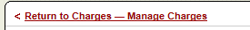
- Continue to reclassify all of the charges on your statement.
- When you have completed reclassifying all charges on your statement, select “Statement Reviewed” in the lower left corner of the screen. Once you select “Statement Reviewed”, you will no longer be able to make changes to your statement.
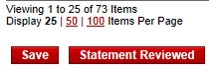
- An email will be sent to your supervisor informing them to review your statement for approval.
- Printing – select “Print Version” at the top of your statement screen. A new screen will appear. Select “Print” at the top of the new screen.
- All receipts must include hand written business purpose. Place your original receipts and the printed report in a PCard envelope and forward the PCard envelope to your supervisor who will then forward it to Purchasing upon approval of your report.

